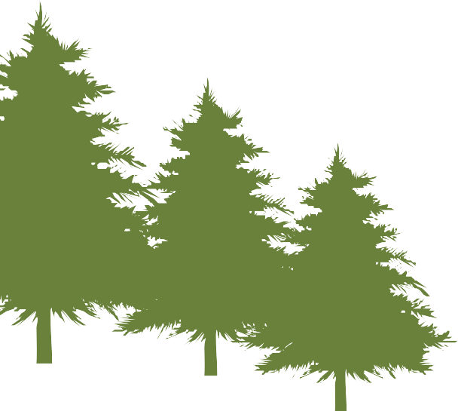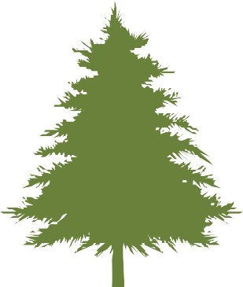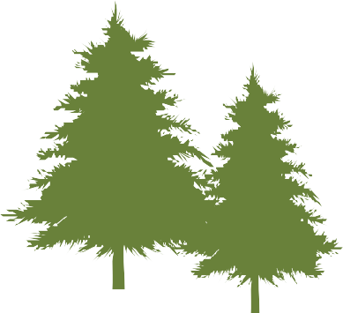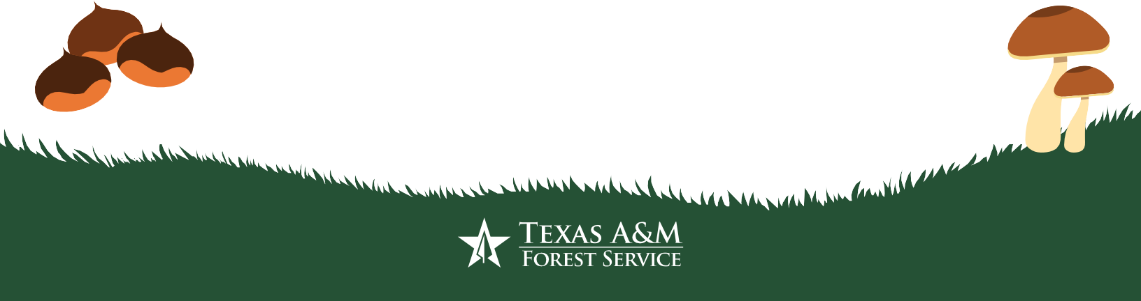

MAKE YOUR OWN
SCAVENGER HUNT

INSTRUCTIONS
Make your own scavenger hunt bingo card (Grades K-12)
Get your friends and family safely outside exploring and learning about Texas’ trees and forests.
STEP 1: Download the Make Your Own Scavenger Hunt Activity.
STEP 2: Decide who your audience is.
(This could be your family, friends, classmates, or members of your community.)
STEP 3: Design a scavenger hunt with tasks your audience can complete. Get creative! (See examples and suggestions below.)

SUGGESTIONS & EXAMPLES
If you need inspiration or help finding ideas, download the Texas Forest Literacy Plan it tells us all the things Texans need to know about trees and forests!

HERE ARE SOME EXAMPLES AND IDEAS TO HELP YOU GET STARTED:

Find an urban forest nearest to your home.
Go to your local park and take a picture of a tree that makes you feel happy. Find an acorn from an oak tree.
Find a food that comes from a tree.
Find a tree that is shaped like a letter – or spell your name using fallen branches.
Find an unusual or uncommon forest product and identify which part of a tree it comes from (wood, sap, bark, cellulose, fruits/seeds/leaves/needles)
How trees improve our health: example- Find a large tree that shades a public space – or – Find a public space that people might use more if there was a tree to provide shade. Remember #healthytreeshealthylives!

Post a photo of the bingo card you’ve created to social media with the hashtags #TexasArborDay and #TXTreeBingo so we can see what you’ve made!

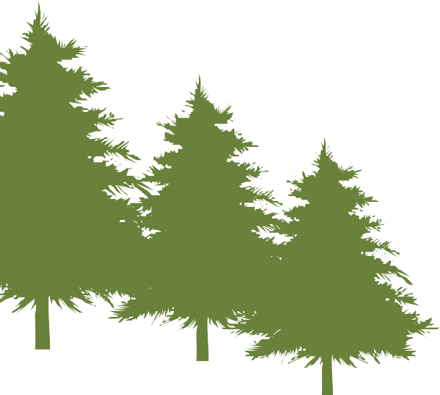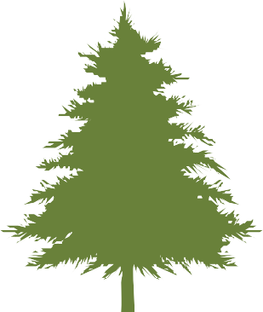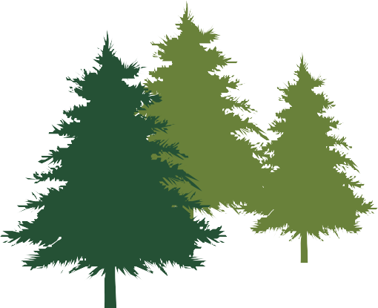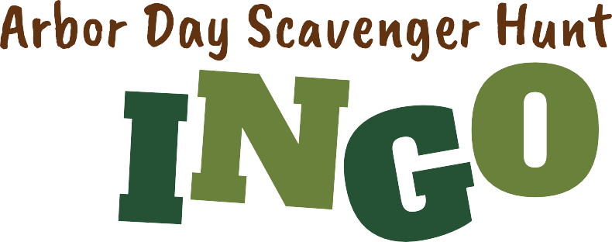
ENGLISH

Created By Example: Molly Loblolly, Houston (Name (or class name), town/city)

